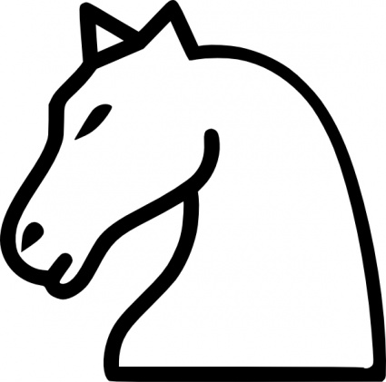



APRENDO ESTA POESIA DEL CABALLO Y LOS COLOREO DE SU COLOR

EL CABALLO

Un pasito como Torre

Un pasito como Alfil

El caballo va saltando

Cambiando de color al fin.



                                                                                                    
                                                                                                    
                                                                                                    

                                                                                                    
                                                                                                    
                                                                                                    

