LLA

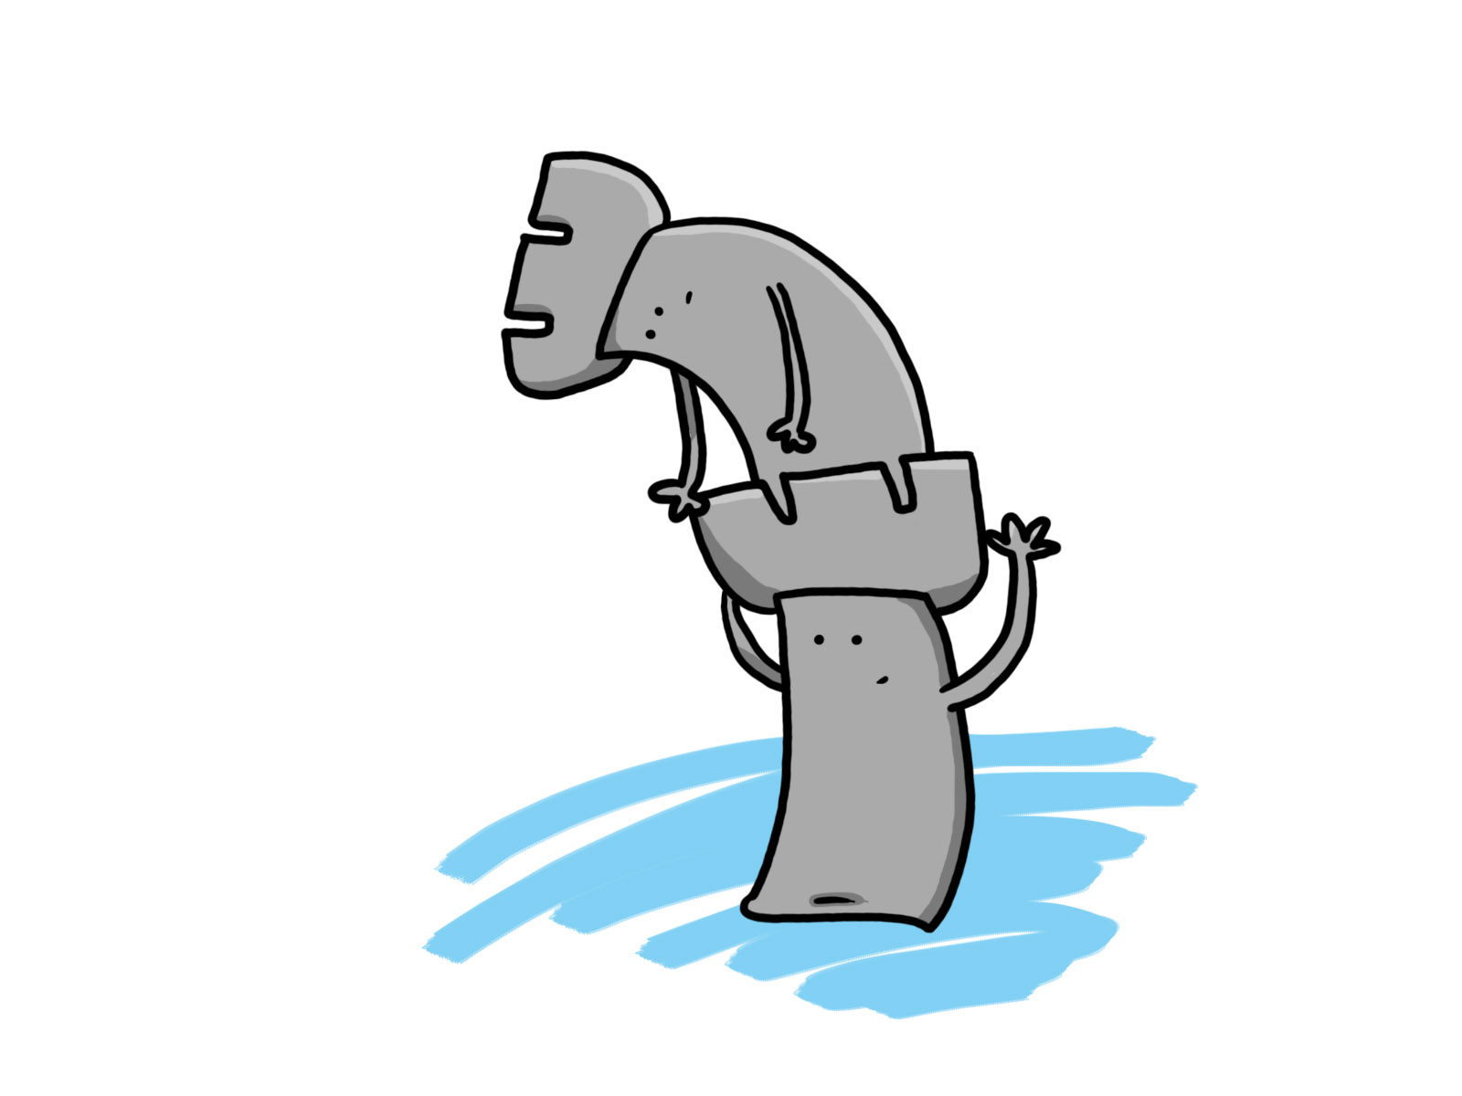

LA ESQUINA DE LAS TORRES

SOY LA TORRE, SOY ESTRUCTURADA,

ME MUEVO PARA ADELANTE, ME MUEVO PARA TRAS.

PARA UN COSTADO, PARA EL OTRO COSTADO,

PERO NUNCA MUEVO EN DIAGONAL.

SI ME ALIO CON MI HERMANA,

MI ATAQUE ES MORTAL.

YO TE AVISO, REY ENEMIGO,

QUE TE VAMOS A ENCERRAR.

VA A COMENZAR LA PARTIDA,

MEJOR ME VOY PARA LA ESQUINA.

VA A COMENZAR LA PARTIDA,

YA ESTOY UBICADA EN LA ESQUINA.





                                                                  
                                                                  
                                                                  

                                                                  
                                                                  
                                                                  